CENTRE AFRICAIN POUR LES APPLICATIONS  DE LA METEOROLOGIE AU DEVELOPPEMENT | 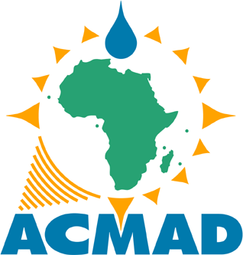 |  | AFRICAN CENTRE OF METEOROLOGICAL APPLICATIONS FOR DEVELOPMENT
Institution Africaine parrainée par la CEA et l’OMM |  | African Institution under the aegis of UNECA and WMO
No …….…./2019/ACMAD/DG/DCE/USAID Niamey, 5th February 2019

M. Johannes Cullmann
Director, Climate and Water Departement,
World Meteorological Organization (WMO)
7 bis Avenue de la Paix, Case Postale N°.2300
CH-1211 Geneva 2, Switzerland
Tel : (+41-22)730-8355
E-mail:jcullmann@wmo.int

Subject: Transfer of unspent funds of the Climate Services for Increased Resilience in the Sahel
project to WMO

Dear Director,

We thank the World Meteorological Organization (WMO) for the support provided for the implementation of the above mentioned project.

A twining exercise involving NOAA/NCEP as the Global Centre, the Regional Specialized Meteorological Centre with activity specialization on Atmospheric Sand and Dust Forecast at AEMET, the Regional Climate Centre at ACMAD and the National Meteorological Service of Niger demonstrated the development and delivery of a climate service for meningitis epidemics surveillance and control. Effective capacity building with transfer of methods, tools and products with interpretive guidance was undertaken. ACMAD is looking forward for similar twining exercise in upcoming projects for the implementation of the Global Framework for Climate Services in Africa.

Please find attached to this letter evidences of closure of the project account and transfer of remaining funds to the WMO account.

Whilst thanking the WMO again, ACMAD avails itself of this opportunity to renew to the WMO the assurance of its high consideration.
Yours Sincerely,

Dr André KAMGA FOAMOUHOUE
Director General of ACMAD

